1. Windows hacking by meterpreter payload

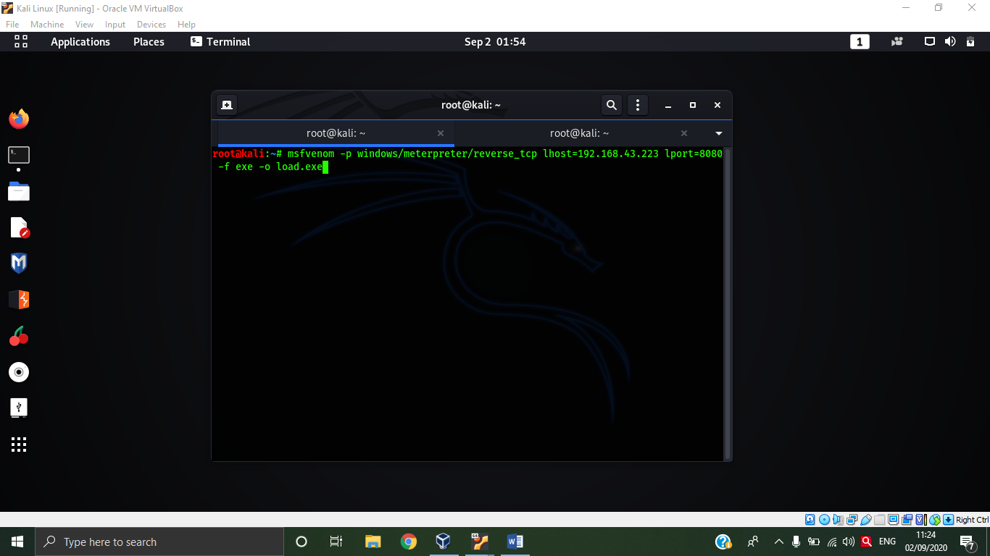

Using terminal and creating a payload using mfsvenom.

Then we will have to install that payload in victim device and run the msfconsole to acces and make a active session over there

